Training Set: no partition (training=test)
Train-Test: 70/30
Stratified Hold Out: TT but train and test have balanced classes
Repeated Stratified TT: repeat TT several times with different random samples
Repeated, Stratified, TVT: 40/30/30
Stratified K-Fold Cross Validation: randomly separates the dataset into K groups. Only 1 group for testing. Repeat K times
Repeated Stratified K-Fold: repeats k-fold several times after reshuffling and re-stratifying the data
Nested Repeated Stratified K-Fold: repeated stratified k-fold using TVT
Leave One Out Cross-Validation: each fold contains only 1 sample
Sum Squared Error:
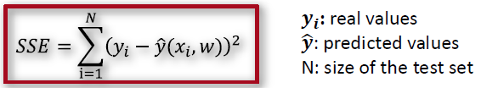
Mean Squared Error: Root Mean Square Error:

Coefficient of Determination:
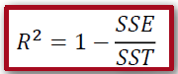, where 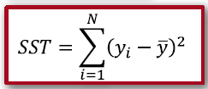
Overfitting: occurs when the model learns specific patterns in the training data that do not generalize to new unseen data – learns noise (ajuste exagerado dos dados de treino)
Underfitting: it happens when the model can’t capture the underlying patterns in the data, resulting in poor performance on both training and test datasets
Mutual
Information:
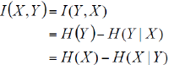
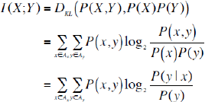
Entre F e C quero apresentar o ranking usando IM: - calcular probabilidades. – calcular IM para (F=S,R=B), (F=S,R=A), (F=N,R=B), (F=N,R=A). – somar esses IMs, o que vai dar IM(F,R). – fazer o mesmo para C. – se I(F,R) maior que I(C,R), então ranking vai ser 1º:F, 2º:C
ReliefF: (ver código)
  - For each sample xi update feature score W[f] for feature f based on feature distance from point xi to nearest hit Hi (same class) and nearest miss Mi (other class)
Find the closest element of the same class to be the Hit, and find the closest element from an-other class to be the Miss. When there are more than two classes, find all the misses, sum them all up, and divide by the number of classes (average).
ANOVA:
Determine degrees of freedom
, k=nGroups
, n=nPoints
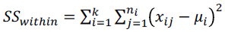
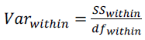
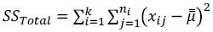
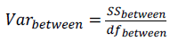
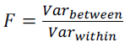
Normalization: Standardization:
If it’s not normally distributed It’s normally distributed
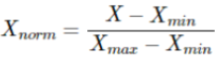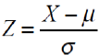
LDA e FDA:
  - Detect direction that maximizes the separation between classes
Maximum separation between means of projected classes and Minimum variance within each projected class
  - 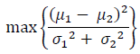
  - 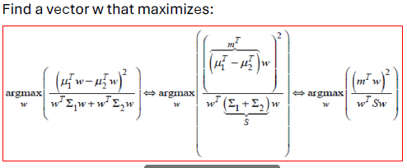
  - 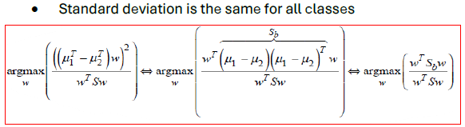
Linear Regression:
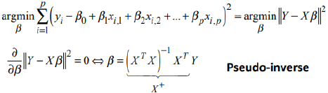
Imbalance Ratio:
Extreme Value Analysis: Interquartile range:
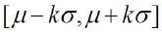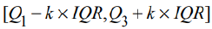
K-Means: IQR = Q3-Q1
- k initial cluster centers. – each point allocated to the closest center. - calculate the mean of x and y for each cluster’s values (new values are the new centers). – stop when nothing changes
DBSCAN:
A point p is a core point if at least minPts points are within distance ε of it (including p). - A point q is directly reachable from p if point q is within distance ε from core point p. Points are only said to be directly reachable from core points. - A point q is reachable from p if there is a path p1, ..., pn with p1 = p and pn = q, where each pi+1 is directly reachable from pi. Note that this implies that the initial point and all points on the path must be core points, with the possible exception of q. - All points not reachable from any other point are outliers or noise points.

MCAR, MAR, MNAR:
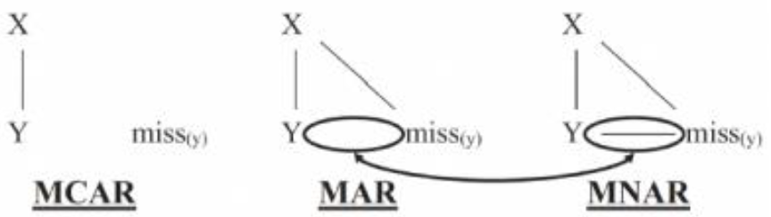
Oversampling:
Naïve Random Oversampling: Randomly duplicate (with replacement) minority data points
SMOTE – já falado antes
Undersampling:
Condensed Nearest Neighbor Rule: Eliminate the samples of the majority class that are far away from the decision border.
One Sided Selection: Tomek Links + CNN
Neighborhood Cleaning Rule: Clean the data while reducing it. - Get the 3-NN of a data sample: If data sample of majority class and 3-NN contradict classification eliminate data sample else if data sample of minority class and 3-NN contradict classification eliminate data samples of 3-NN that belong to majority class

